Round 1
Lancs National Schools

2019-20

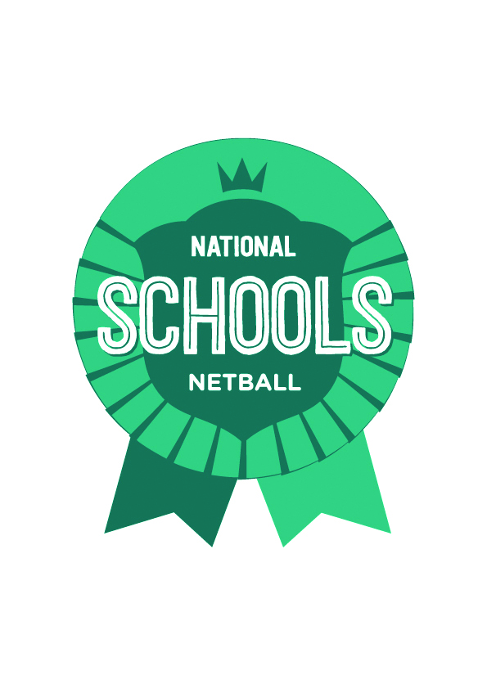
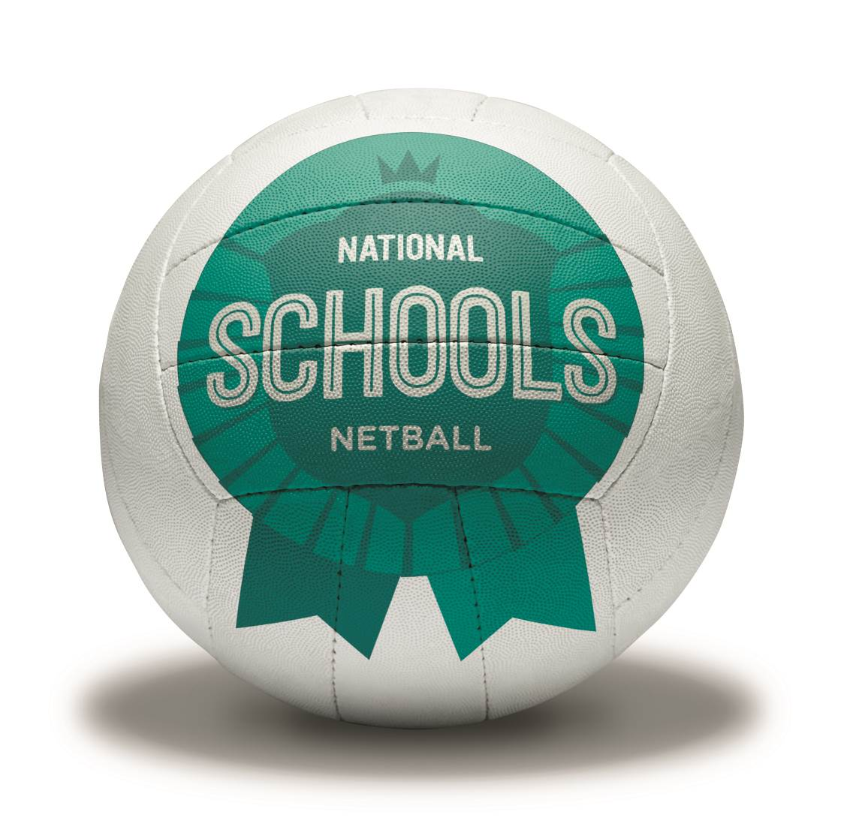

Tuesday 5th November

Playing Schedule,
Rules & Regulations &
Important Information

Venue
St Cecilia’s RC High School
Chapel Hill, Longridge
Preston, Lancashire
PR3 2XA

LOC details

Jane Moodie
Lancs County Netball Competition Officer
Mobile: 07940 549439
Email: janesnetball4all@gmail.com

Competition Referees

Jane Moodie & Gill Walker

Appeals to be sent to

Anne Wignall
Lancs County Chairperson
A_Wignall@hotmail.co.uk

Entry Forms & Fees
Entry Fee is £25 (does not include umpires fees)
Umpire fee per team is £25 if unable to provide your own.
Cheques payable to LCNA
(include the name of your school on the back)
Return to Jane Moodie (LCNA) at
22 Longton Rd., Burnley, Lancs BB12 0TF

General information

Tournament Referees: Jane Moodie & Gill Walker
The tournament shall be played to EN rules. The Tournament Referee will decide on any matter arising during the course of the event. The referee’s decision shall be final.

Venue
St Cecilia’s RC High School, Chapel Hill, Longridge, Preston, Lancs PR3 2XA. There is parking at the venue however please notify me if you are travelling via a coach.

Registration
On arrival please report to the Organiser’s table to register any teams and volunteers at 11.00am. Officials meeting at 11.40am. First matches at 12.00pm.

Injuries & Substitutions
There is no injury time, but common sense must rule here. If it is safe to move the injured player then do so and replace as per England Netball rulings. If it is not safe to move the injured player, the score of the game at the point of injury will stand as the final result. Any player who is bleeding should be asked to leave the court or preferably treated at the side of the court immediately to cover the wound. Substitutions for injuries can be carried out as rolling subs during the game. Please inform an umpire of the change.

Team Bench
Coaches/teachers, manager, physio and players are the only people allowed on court and they must stand to the right of the post where their team is defending in the first half and must not move.

Umpires & Scorers
UMPIRE CARDS WILL BE PROVIDED
Umpires will not be automatically provided for the tournament. However if you cannot provide an umpire then a fee of £25 must be paid per team and a request sent to Jane Moodie to arrange cover. Scorers must be provided by each team and they can be of any age as long as they are competent. Scorers must stand together by the court side and shout out the score.
This is an ideal opportunity for any person signed up to ‘Pass on Your Passion’ with EN to log some hours. http://www.englandnetball.co.uk/youth-zone/poyp

Start of Play
All teams must be on court and ready to play at the round stated. Captains should toss for centre pass before the start of each game and notify the umpires of the result.

Late Arrivals
If a team arrives later than 1 minute on court when the hooter has sounded then the non-offending team will be awarded 5 goals. If the team arrives after the half-time hooter, then the points will be awarded to the non-offending team and a score of 5-0 recorded. This will be timed by the umpires.

Timing
A central hooter will sound 5 minutes before the start of the tournament. Teams playing the first round should go to the court immediately.

Duration of Matches
Matches will consist of two equal periods of 6 minutes 1 minute at half time. There will be two minutes between games but if teams are ready to start prior to this then matches will commence. It will be central timing and a hooter will signify the start and end of each match including half time. However, all games will start and finish on the umpires whistle.

PLEASE NOTE IT IS ADVISABLE TO GO OFF THE ROUNDS NOT OFF THE TIME. NO ALLOWANCES WILL BE GIVEN TO ANY TEAM ARRIVING LATE BECAUSE THE TIMING IS OUT!

Scoring
5 points for a win
3 points for a draw
1 point if the losing team score over 50% of the opponents score.

In the event of a tie on points, placing will be decided by applying the following criteria:-
- goal difference i.e. goals for minus goals against.
- then by goal average i.e. goals for divided by goals against.
- finally by the number of goals scored.

Extra Time
In the event of a draw teams will continue to play until the next goal is scored, the team scoring the goal will be deemed the winner.

Inclement Weather
In the event of inclement weather the tournament will proceed unless it is deemed not safe or fit to play. If this is the case a decision will be carried out by 7.30am that morning and if it is to be cancelled & rearranged then it will be posted on the Lancs County Netball Website. A text will also be sent to the name of the organiser of each school team.

Health & Safety
Spectators must remain outside and off the courts. Smoking is not permitted in or around the courts. No dogs are allowed as the school is still open for its students.

Supervision Responsibilities
All schools must supervise their students at all times. The Organisers will not be responsible for this.

Conduct
It is unacceptable of spectators/players to intimidate an umpire or players in anyway. A verbal warning will be issued to any person who the umpire feels is behaving in an unacceptable manner. If problems still occur the offending party will be asked to leave the courts for that round. If it persists, the offender will be banned from either the side of the court or spectating on the perimeter for the rest of the day. Refusal to leave will result in the game being stopped and 5 points being awarded to the non-offending team.

Litter
Black litter bags will be around the area and one will be given to each team. PLEASE use them and keep the area tidy. It is not acceptable to litter the School premises.

Refreshments
These will be available on site.

Lost Property
Any property found or lost should be reported to or handed in at the registration desk.

Closing Ceremony and Presentations details
The time and place will be on the fixtures.

First Aid
There will be no designated First Aider at the venue so please make sure your team provide their own qualified First Aider and First Aid Kit.

Liability
Lancs County Netball Association and the host school cannot accept liability whatsoever in respect of personal injury, which players, officials or spectators sustain through their own negligence. They do not accept responsibility for any loss of valuables or clothing.

Gazebos & Tents
There is a large grassed area at the side of the courts for Gazebos & tents. However please make sure all pegs are removed as this is a school playing area. If the weather is not great then gazebos & tents will have to be set up on the concrete area.

Code of Conduct

Code of Conduct for Athletes

Our Codes of Conduct require the highest standards of conduct from everyone involved in netball to ensure that their behaviour and actions meet the values and standards expected at all times. Everyone must conduct themselves in an honest, fair, impartial and transparent manner.

Our Codes of Conduct are applicable to all aspects of the Sport and are driven by England Netball’s Values (Respect, Teamwork, Achievement and Fun) and the Guiding Principles (set out above).

I will Respect:

- The rules, regulations and requirements of the Sport, including, but not limited to, any competitions in which I participate either directly or indirectly

- The rights, dignity and worth of all people involved in netball, regardless of gender, marital status, race, colour, disability, sexuality, age, occupation, religion or political opinion

- The rights, dignity and worth of Children, Young People and Adults at Risk and ensure that I am aware of the Safeguarding best practice guidelines and procedures when interacting with them.

- Confidentiality and the sensitivities of information I hold on other individuals.

- Netball and the individual’s reputation and not take any action or make inappropriate comments about a fellow participant, coach, official, volunteer or member of England Netball’s staff that will bring the Sport or those associated with delivering the Sport into disrepute, including making comments on social media technology. I will respect EN’s guidance and policies on social media technology.

- The position I hold within Netball and always conduct and dress myself in an appropriate manner.

- The result of the game and will not attempt to offer, offer or accept either directly or indirectly any consideration whatsoever in return for influencing or attempting to influence the result or seek to achieve personal gain on a result which I can influence by betting on any match or event where I am participating, either by playing, coaching or officiating, or through direct or indirect involvement.

Netball is based on Teamwork, therefore I will:

- Not abuse or misuse any relationship of trust or position of power or influence held by me in my team, be that my playing team, Club, County, Regional or England Netball

- Be on time, dressed appropriately and ready to give my full attention to the role I am carrying out within Netball

- Recognise that individuals bring different qualities and attributes but “together we will excel”.

- Welcome new members, volunteers, and connected participation and cooperate with Members, Connected Participants, colleagues, coaches, officials and administrators already in the Sport.
I recognise individuals participate in Netball to achieve and have fun, therefore I will:

- Recognise the achievements of others and applaud their successes

- Endeavor to ensure that all involved in the Sport optimise their potential by promoting the positive aspects of the sport and never condoning the use of inappropriate or abusive language, inappropriate relationships, bullying, harassment, discrimination or physical violence.

- Not impinge on others enjoyment of the Sport or my performance by consuming alcoholic drinks or smoke immediately prior to or while participating in the sport, or while safeguarding children, young people or vulnerable adults

- Ensure that everyone has the opportunity to participant in a fair, honest environment by rejecting cheating, abiding by the Anti-Doping policies and not taking illegal substances immediately prior to or while participating in the Sport.

- Display modesty in victory and graciousness in defeat; be sporting – whether I win or lose; always acknowledge the other team and the umpires at the end of the game with a hand shake or three cheers.

- Never argue with an official or participant during a game and listen to and cooperate with officials’ decisions

- Control my temper; I understand that verbal, emotional and physical abuse of officials, coaches, spectators or participants, or deliberately distracting or provoking a participant, coach or official is not acceptable or permitted behaviour in netball

- Enjoy the game and ensure other can also enjoy it.

I will endeavour to abide by this code of conduct and promote it to others. I understand that if I fail to follow the code, the England Netball, the Regional Association or the County Association may take action against me under the Disciplinary Regulations which may result in Sanctions including fines and suspension.
Code of Conduct for Athletes

EN has Codes of Conduct across all aspects of the sport, which is driven by its’ core values of
leadership, integrity, teamwork and excellence. Our codes require the highest standards of conduct from everyone involved in Netball to ensure that their behaviour and actions meet the values and standards expected of them at all times.

Code of Conduct for Coaches, Umpires, Table Officials, Team Managers, Teachers, Assessors, Testers, Trainers, Verifiers, Mentors and Volunteers

The Code of Conduct state the values and standards expected at all time. In addition to these, when in my capacity as a coach, umpire, table official, team manager, teacher, tutor, assessor, tester, trainer, verifier, mentor or volunteer, I will also:

- Be a positive role model for netball by acting in a way that projects a positive image of my role within netball and being fair, considerate and honest with participants and officials

- Display high standards in my language, manner, punctuality, preparation and presentation to ensure that all time spent with me by participants or colleagues is a positive experience

- Exercise reasonable care and skill when carrying out my duties, including but not limited to keeping up to date with the latest practices and developments by taking up further education and other personal and professional development opportunities

- Be consistent, independent and demonstrate complete impartiality through exercising reasonable care and skill to enforce the rules of the game by applying them fairly and to effect control of the game

- As a coach, seek to inspire and motivate in accordance with an individual’s abilities to enable them to play to the best of their ability and realise their potential

- As a coach, provide athletes with planned and structured training programmes appropriate to their abilities and goals by ensuring that equal attention and opportunities are available to all, including those requiring a modified plan due to sickness or injury

- As a tutor, assessor, tester, trainer, verifier or mentor, provide candidates with the appropriate information, planned and structured programmes appropriate to their needs and goals, ensuring that equal attention is applied, and to provide appropriate feedback following observation of a session

- Be mentally and physically fit to carry out my role within netball

- Ensure that the training and/or competition environment is safe and appropriate for the age, physical and emotional maturity, experience and ability of the athletes

- Ensure that I follow instructions and comply with all health and safety regulations that apply to the role I am undertaking.

I will endeavour to abide by this code of conduct and promote it to others. I understand that if I fail to follow the code, the England Netball, the Regional Association or the County Association may take action against me under the Disciplinary Regulations which may result in Sanctions including fines and suspension.

Code of Conduct for Parents/Carers

The enjoyment and safety of your child when involved in a netball activity is of paramount importance to England Netball. Every child will be encouraged and asked to ensure that their behaviour and actions meet the values and standards expected of them at all times. As parents, you are asked to support our Codes of Conduct and embrace the spirit of our game.

As a parent/carer, I will:

- Encourage my child to play within the rules and respect officials’ and coaches’ decisions
- Support my child’s efforts and performance, give positive comments that motivate and encourage continued effort and learning
- Understand that competition is about winning and losing, so results are always accepted without undue disappointment
- Be a positive role model to my child by helping them work towards skill improvement and good sportsmanship
- Remember that children learn best by example; I will applaud good play by both my child’s team and their opponents
- Thank the coaches, officials and other volunteers who give their time for my child and not interfere with their decisions
- Help when asked by a coach or official
- Respect the rights, dignity and worth of all people involved in the game, regardless of gender, marital status, race, colour, disability, sexuality, age, occupation, religion or political opinion
- Read the rules of the sport to understand better what I am watching and discussing with my child
- Promote this code of conduct to other parents, carers and supporters
- Be aware of my child’s club safeguarding policy and ensure that any concerns are reported to the club’s safeguarding officer or England Netball’s Lead Safeguarding Officer.

As a parent/carer, I will not:

- Pressure my child in any way; I know that this is their sport not mine
- Use inappropriate language, harass athletes, coaches, officials or other spectators
- Criticise or ridicule my child for making a mistake or losing after the game
- Force my child if they are unwilling to participate in the sport
- Arrive at a netball activity under the influence of alcohol or drugs
- Use Social Media technology to bring the game into disrepute or make an inappropriate comment about an athlete, coach, official, volunteer or member of England Netball staff
- Consume illegal substances either immediately prior to or while being at a netball activity where my child is participating in the sport
- Consume alcoholic drinks or smoke either immediately prior to or while being at a netball activity where my child is participating.

Lancs County Netball Association would like to say
Thank you, Good Luck and Enjoy the Day!

